Mock Paper 1

Directions: working in small groups, you will be responsible for creating the 4 questions related to the documents listed below. You may collaboratively work via a google document or other collaborative platform (Office 365, etc.).

Source A:

Excerpt from “What is Fascism?” by Benito Mussolini, originally published in the Italian Encyclopedia, 1932.

For Fascism, the growth of empire, that is to say the expansion of the nation, is an essential manifestation of vitality, and its opposite a sign of decadence. Peoples which are rising, or rising again after a period of decadence, are always imperialist; and renunciation is a sign of decay and of death. Fascism is the doctrine best adapted to represent the tendencies and the aspirations of a people, like the people of Italy, who are rising again after many centuries of abasement and foreign servitude. But empire demands discipline, the coordination of all forces and a deeply felt sense of duty and sacrifice, the character of many forces in the State, and the necessarily severe measures which must be taken against those who would oppose this spontaneous and inevitable movement in Italy in the twentieth century, and would oppose it by recalling the outworn ideology of the nineteenth century – repudiated wheresoever [sic] there has been the courage to undertake great experiments of social and political transformation; for never before has the nation stood more in need of authority, of direction, and order.

Source B:

Excerpt from War and Peace in Soviet Diplomacy by T.A. Taracouzio, published by Macmillan, New York, USA, 1940, p. 199. Taracouzio was a writer who produced several books on the Soviet Union and its diplomacy and wrote several articles for the US-based journal Foreign Affairs.

Nine days later he [Soviet Foreign Minister Litvinov] referred to these considerations as the real reason why the League should fulfil its purpose to the greatest degree possible [with regard to Italy’s invasion of Abyssinia]. This defense of the League Covenant became the primary concern of the Soviets, and to that end the USSR was to be ‘second to none in the legal discharge of assumed international obligations, more especially in the noble task of securing for all nations the blessing of peace, which mankind never valued or appreciated so much as it does now after the relatively recent orders.’ This meant Soviet loyalty to Article 16 of the Covenant, whose provisions called for sanctions. The Soviets insisted on their application to the fullest extent.

Source C:

Excerpt from The League of Nations: Its Life and Times, 1920-1946 by F.S. Northedge, published by Holmes & Meier, New York, USA, 1986, p. 243. Northedge was a professor of international relations at the London School of Economics, UK, writing numerous books on the subject as well.

The fact is that the British and French Governments never had any intention of using force against Italy to stop its advances in Abyssinia, or even of closing the Suez Canal, which would have locked Italian forces in East Africa in a trap. Nor had any other country, though all were ready to cheer Britain and France from the side-lines, had they gone into action. Laval even regarded an oil embargo as a form of military sanction since he considered that it would have military consequences, and he opposed it for that reason. It was equally evident that, for his part, Mussolini did not intend to be prevented from conquering his victim by anything short of superior force. The conquest of Abyssinia was too important to his foreign policy; he had invested too much money, too much of his own political future, in it…In these circumstances, what course remained for the chief League Powers except to try to reach a compromise settlement which might at least keep some part of Abyssinia outside the new Roman Empire [Mussolini’s Italy]? The brutality and cynicism, the blatant deception, of the Hoare-Laval proposals might be deplored, but their logic was less easily condemned.

Source D:

“The Jap in the Vase.” A cartoon by Sidney ‘George’ Strube. Retrieved from British Cartoon Archive at the University of Kent (https://archive.cartoons.ac.uk/Record.aspx). Strube was a British Cartoonist who worked at the Daily Express from 1912 to 1948. The Daily Express is a British newspaper started in 1900.

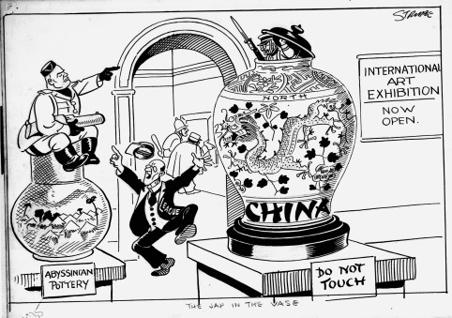

Questions related to Sources.

