Steps for using VideoNot.es App in Google Drive
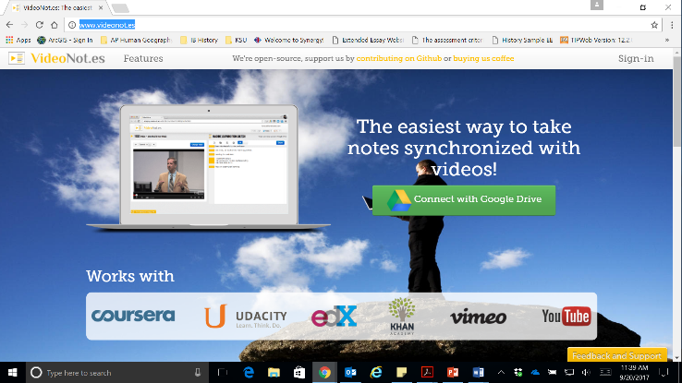
Step 1: Go to http://www.videonot.es/
Step 2: Click Connect with Google Drive.
My advice would be to already be logged in to google in another browser. This will automatically sign you in and link the accounts. If you are NOT signed in to your G account, sign in.

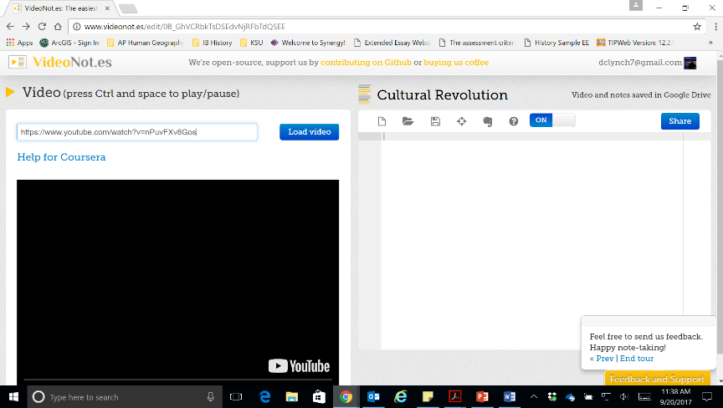

Step 3: Insert URL for video and hit load video to the right of the URL field.
When this step is complete, a tutorial should pop up. It will run through all options available to you. Quickly read each box that pops up. Title your notes something appropriate.

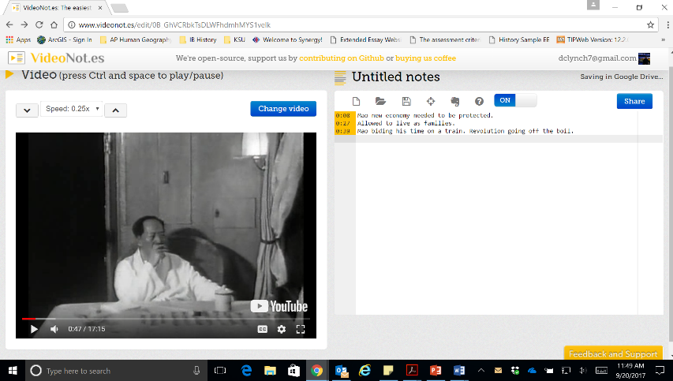
Step 4: Hit play and begin recording your notes. The notes will automatically synch to the timestamp in the video. Hit enter to create a new line. If you hit backspace and return to a previous line, the video will synch to THAT moment when you began taking notes – keep that in mind if you’ve gone a while without jotting information down. You can also click the notes themselves to review portions of the film based on the notes you took.
Be sure to hit the floppy disk symbol to save. Your notes will be saved in your G drive. When you open this file, it will automatically connect you with the Videonot.es webpage and the notes where you left off (or in entirety if you’re done).

